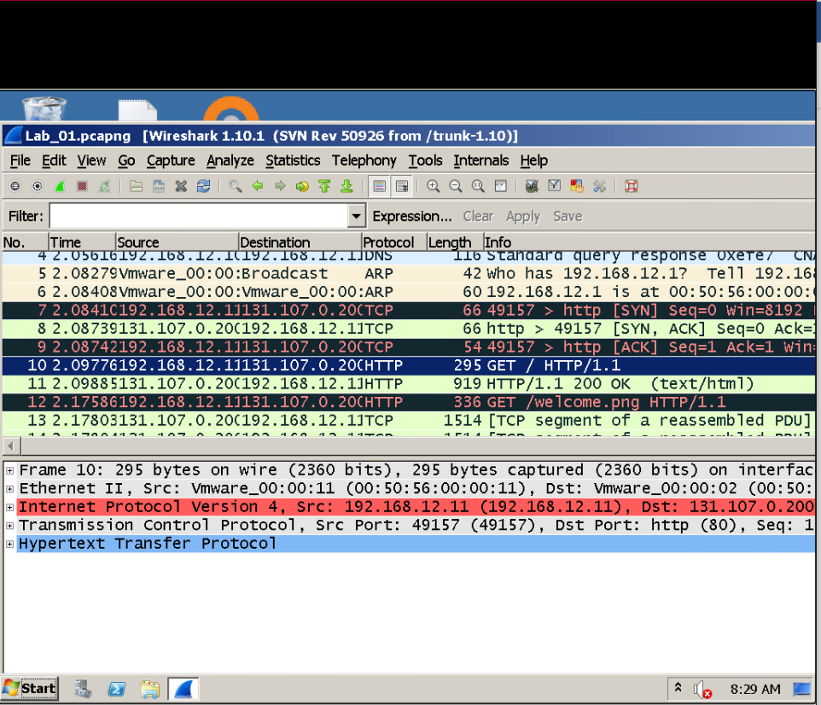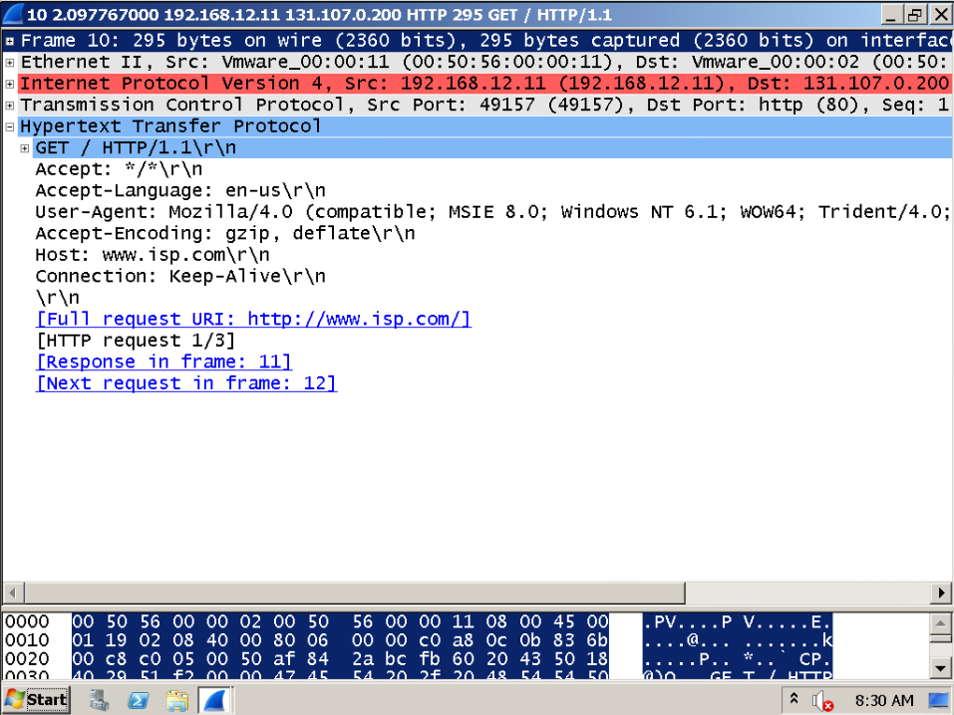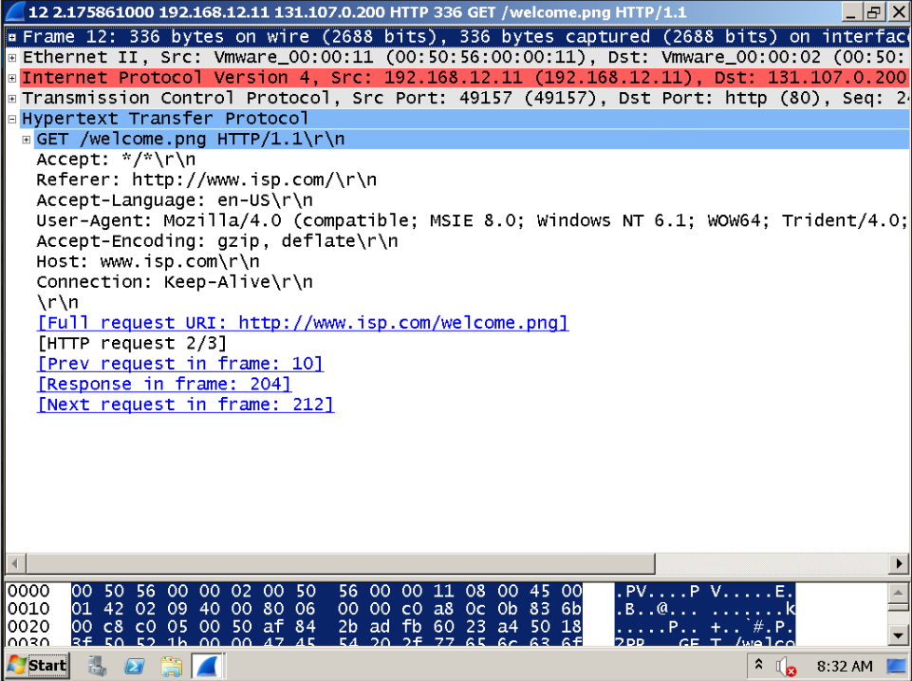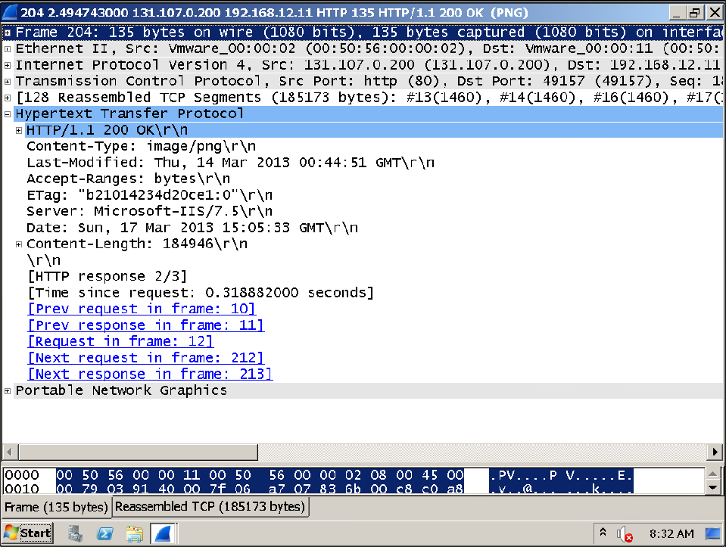What is the PDU associated with the top three layers of the OSI model? data

What HTTP message type is used to request data? Request(GET)

What HTTP message type was used to signify the image was successfully transferred to the client? Response(OK)

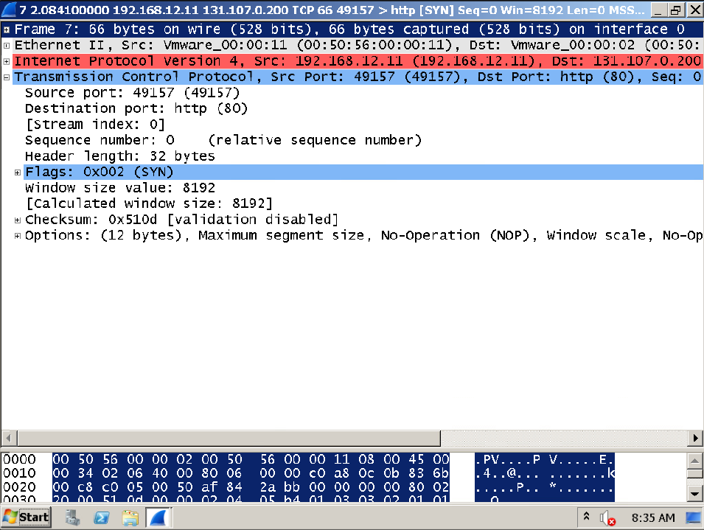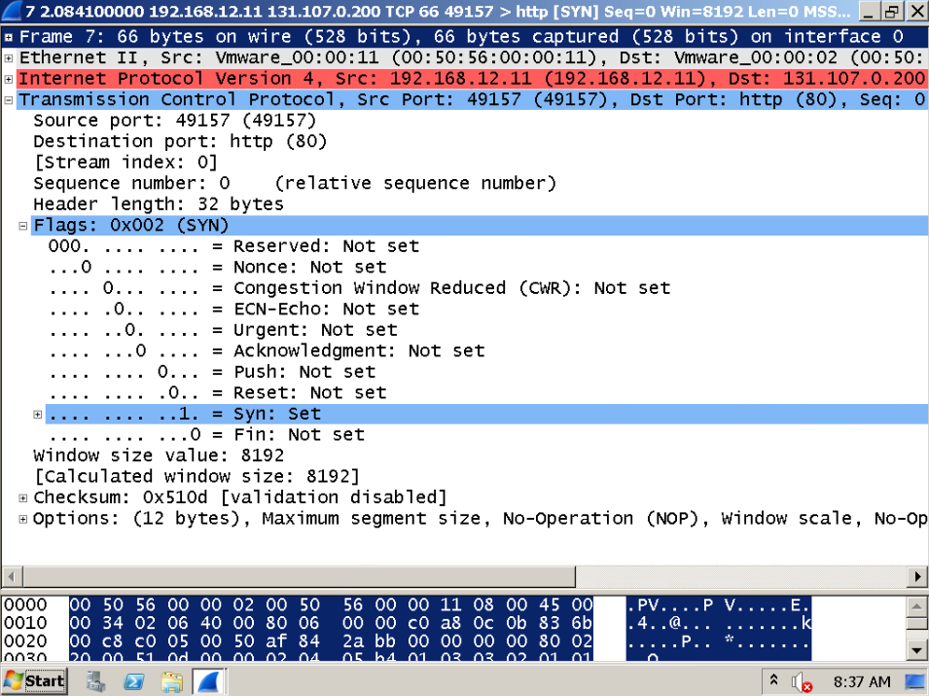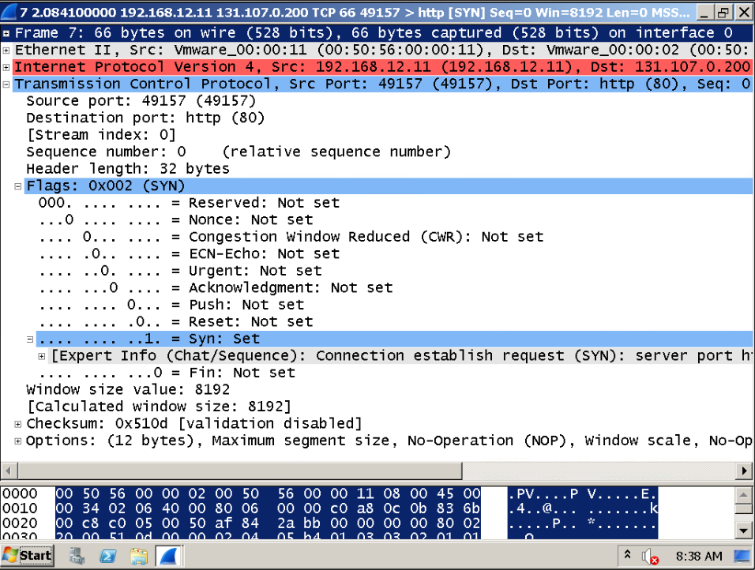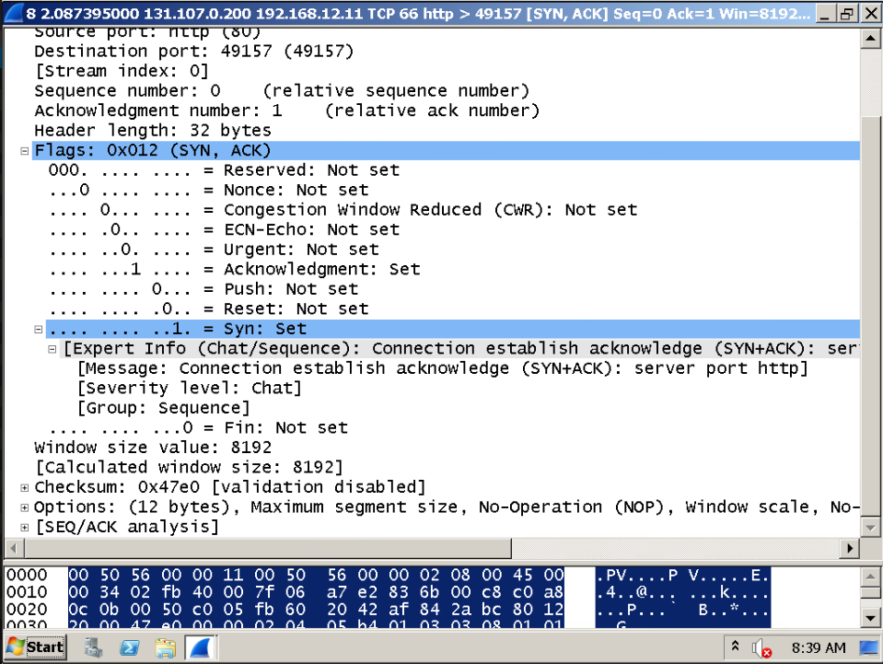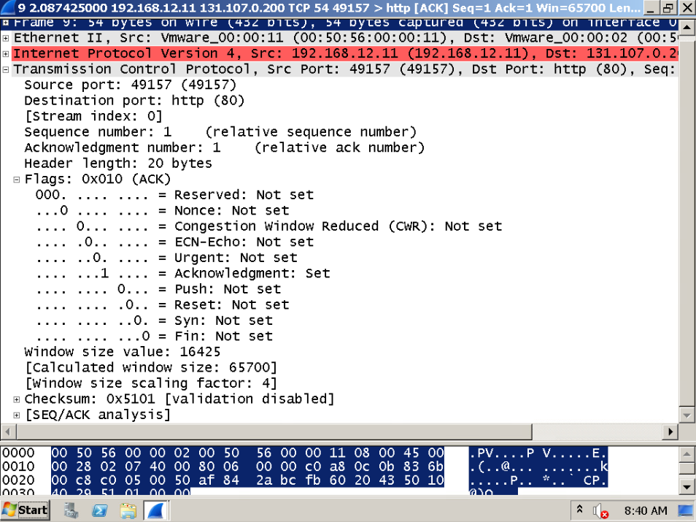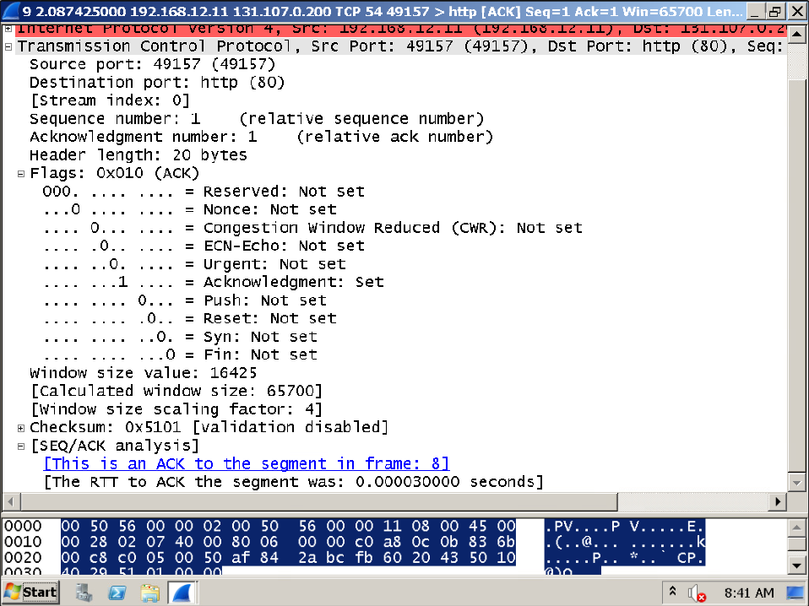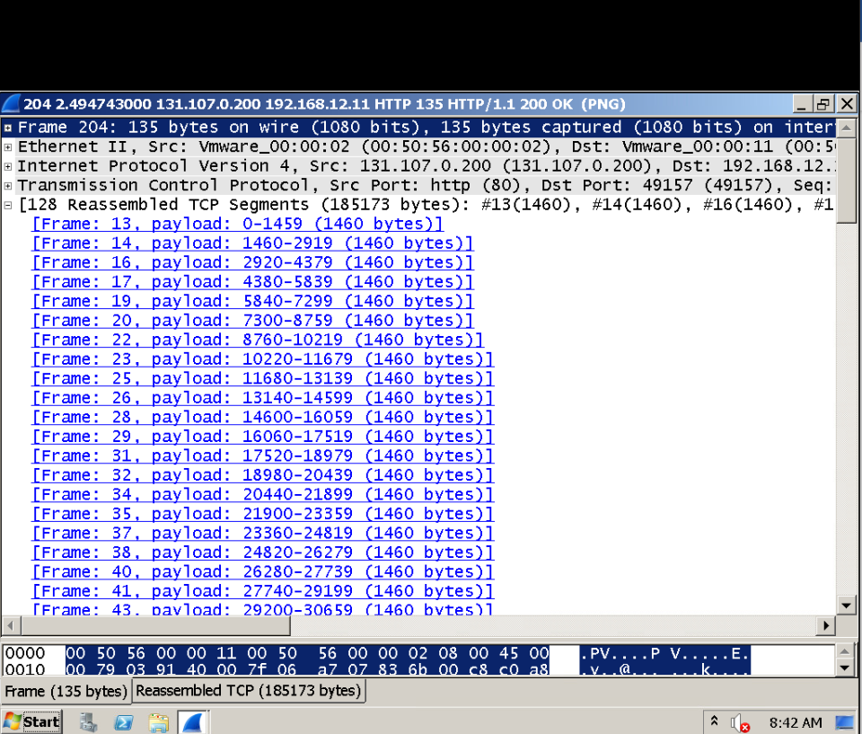In Segment Protocol Data Unit section, Step 2a, what is the source port for the conversation? 49157

In Segment Protocol Data Unit section, Step 2b, what is the Well Known Port number for the HTTP protocol? 80

Identify which flags are set in each segment of the three-way handshake. There are 3 segments.SYN, SYN-ACK, ACK

The port number 49157 is known as this type of port because it is randomly generated when theconversation is initiated. Dynamic

The port number 80 is known as this type of port because it is assigned to the HTTP protocol by5.IANA. Well known

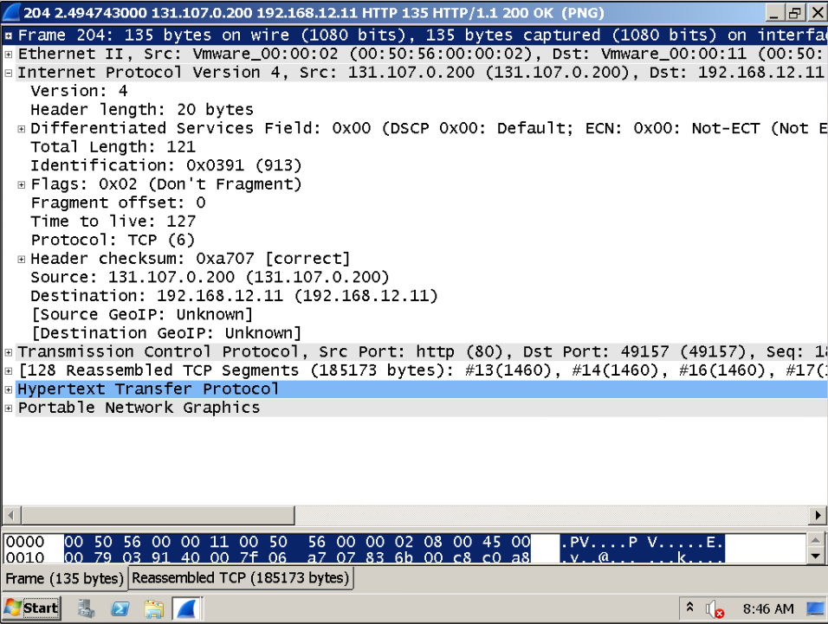What is the typical header length for the IP protocol? 20 bytes

What device decreases the TTL value whenever a packet traverses it? router

What is the PDU associated with the network layer of the OSI model? Packet

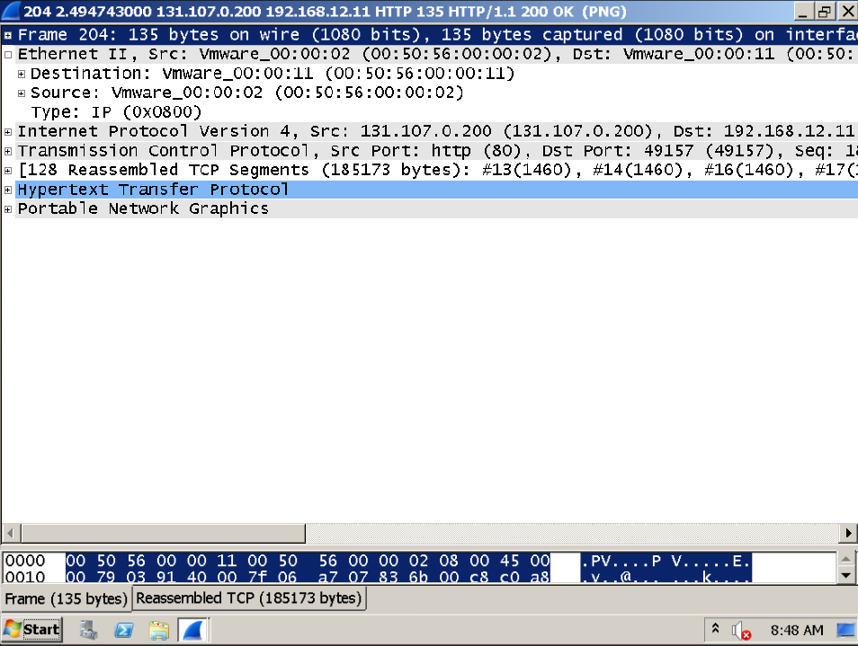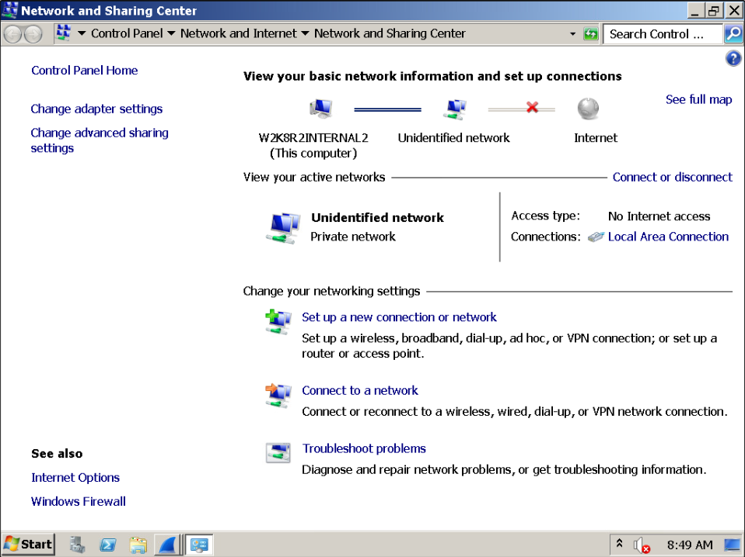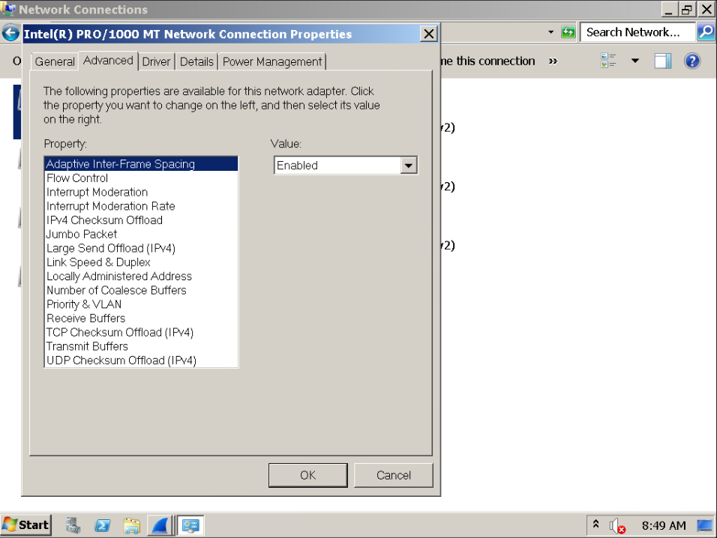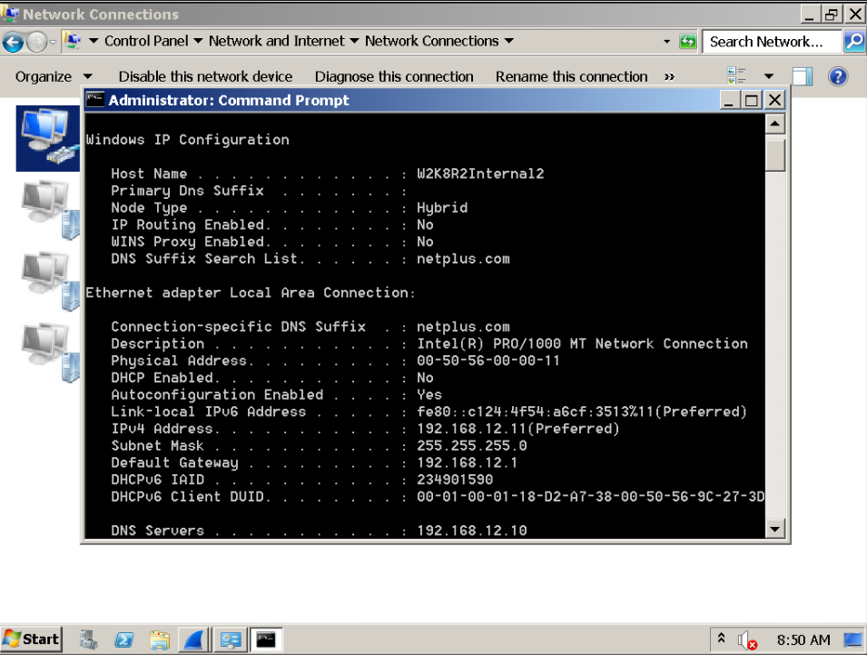How long is a MAC address in bits? 48

How long is a MAC address in bytes? 6

What is the first half of a MAC address known as? OUI

What command can be used on a Windows machine to view the MAC address? Ipconfig /all

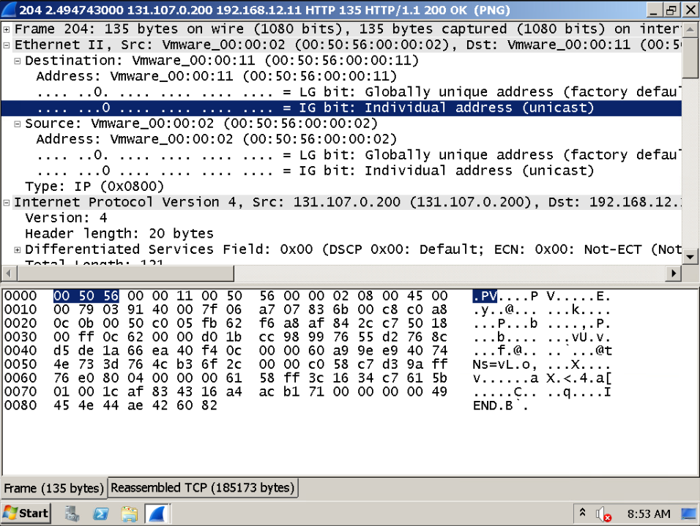

Challenge 1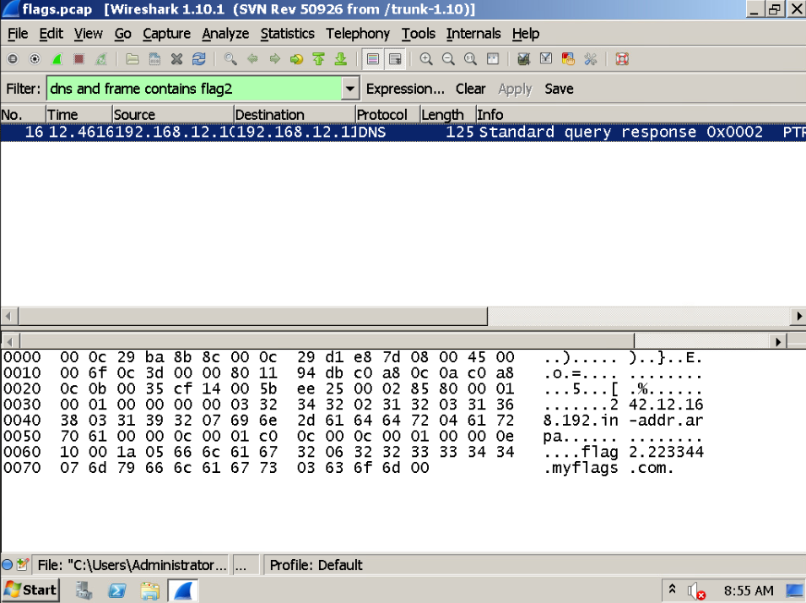challenge 2

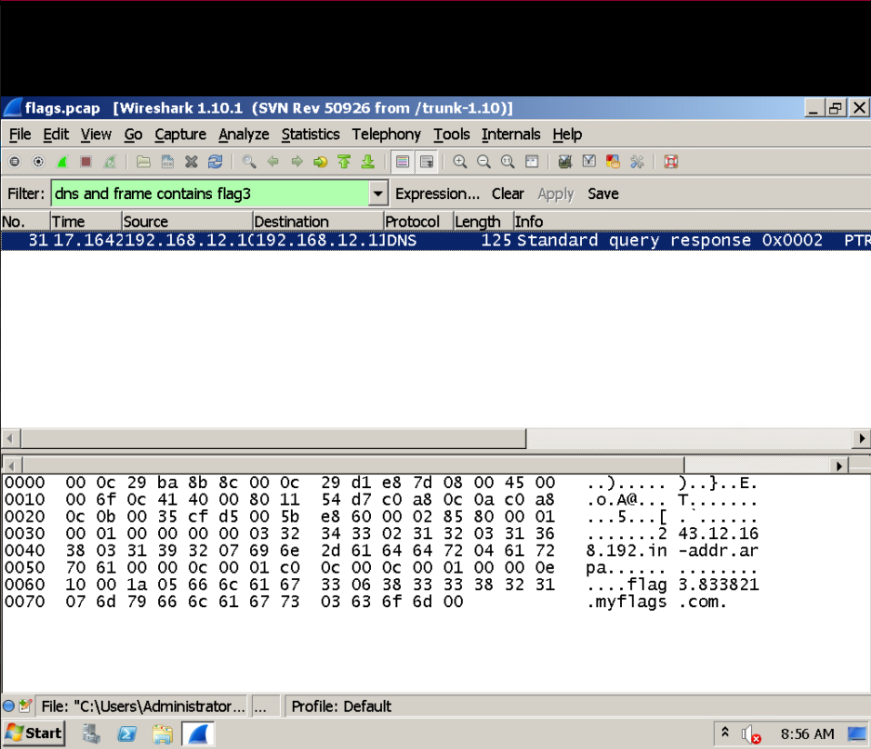

Challenge 3

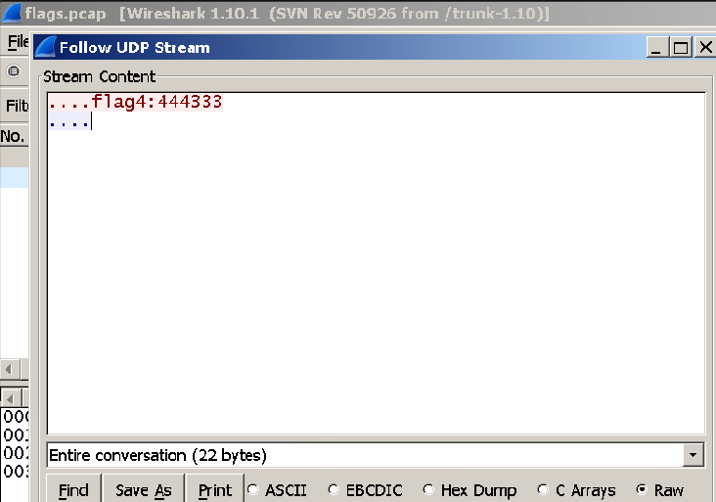Challenge 4

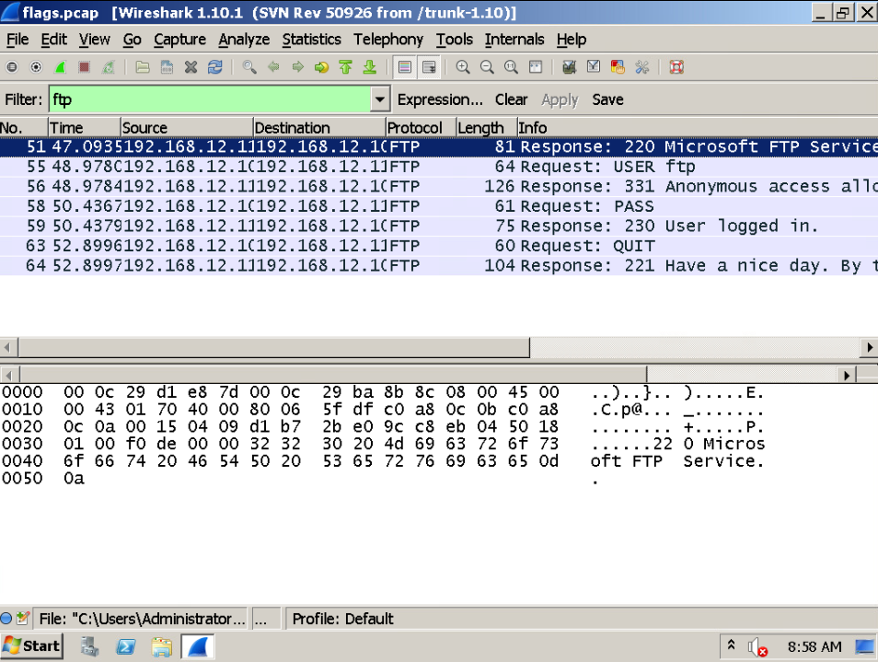

Challenge 5

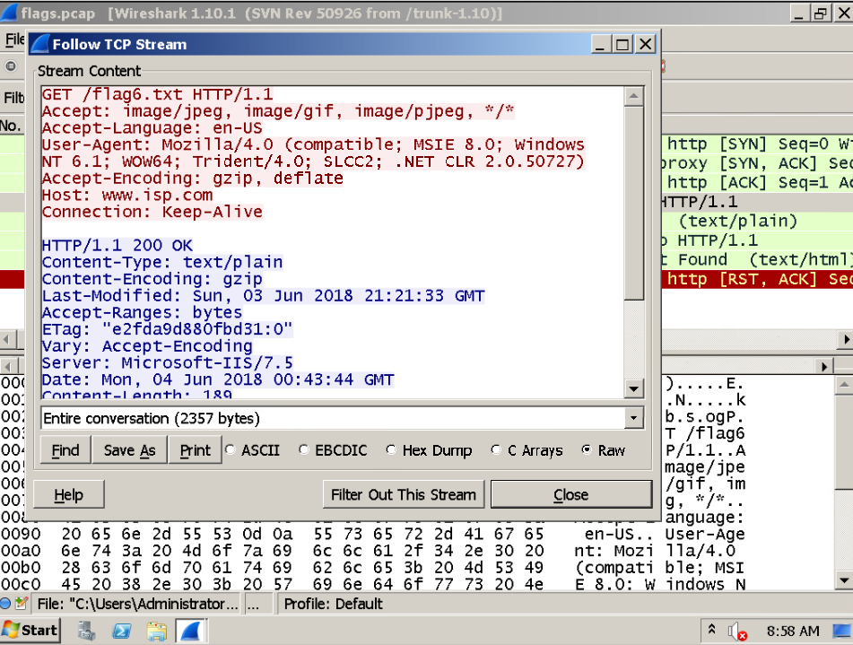

Challenge 6 “press stop”

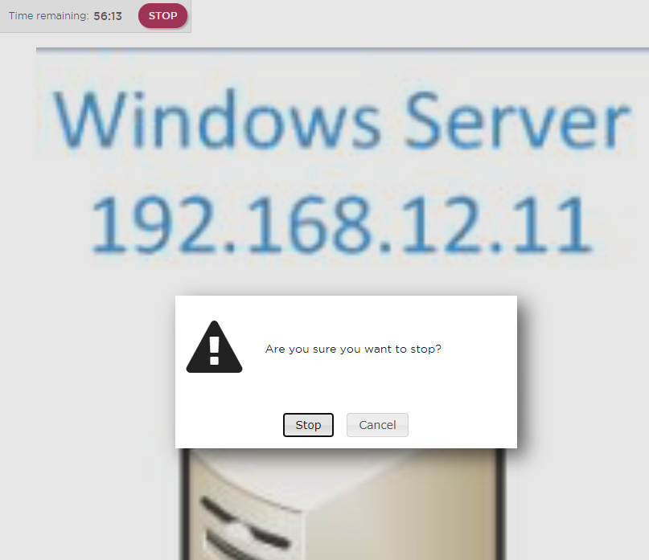What is the PDU associated with the physical layer of the OSI model? bits

True or false – a bad cable is considered a physical layer issue? true

True or false – a misconfigured IP address is considered a physical layer issue? false